**Services and Housing Survey**

**Preliminary Relationships 10/25/2018**

**(based on snapshot of the data a few days earlier)**

**Where did people find the survey?**

* email - 424 respondents match ‘.*email.*’ and 57 match ‘.*forward.*’
* town - 132 respondents match ‘.*town.*’
* facebook - 67 respondents match ‘.*facebook.*’
* mavens - 62 respondents match ‘.*maven.*’
* lexington list - 46 respondents match ‘.*lexington list.*’
* recreation - 41 respondents match ‘.*recreation.*’
* human services - 26 respondents match ‘.*human.*’
* community center - 23 respondents match ‘.*community.*’
* neighbor - 22 respondents match ‘.*neighbor.*’
* yahoo (prob lexington list) - 19 respondents match ‘.*yahoo.*’
* lexington at home - 14 respondents matched ‘lex.*home’
* chinese - 10 respondents match ‘.*chin.*’
* lexfun - 7 respondents match ‘.*lexfun.*’
* tmma - 7 respondents match ‘.*tmma.*’
* pto - 6 respondents match ‘.*pto.*’
* indian - 3 respondents match ‘.*indian.*’
* don’t know - 3 respondents match ‘.*don’t know.*’
* spouse - 3 respondents match ‘.*spouse.*’
* internet - 2 respondents match ‘.*internet.*’
* lrtc - 2 respondents match ‘.*lrtc.*’
* husband - 1 respondent matches ‘.*husband.*’
* wife - 1 respondent matches ‘.*wife.*’

Some of these double count above, such as town & email, or recreation and email, etc.

Residential Exemption may impact renters. Survey responses highlight the high housing stress experienced by renters.

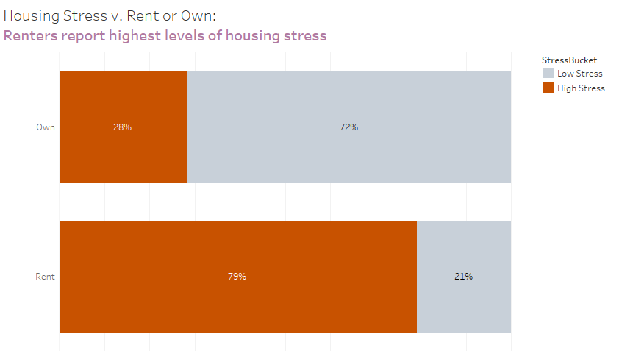

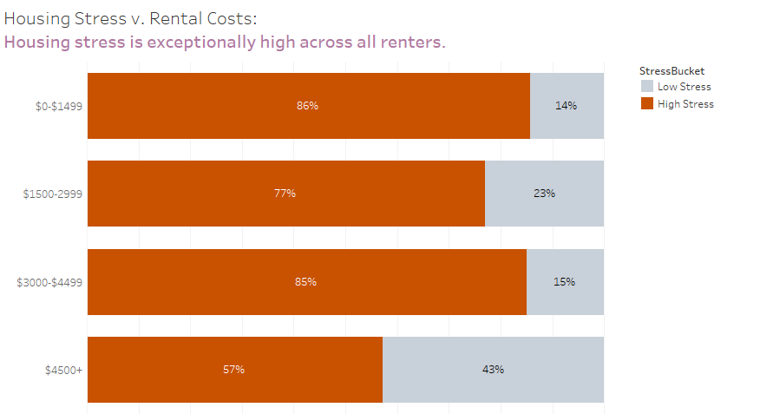

Residential Exemption adjusts taxes paid by owners in relation to property value. Surveyed stress levels are correlated with property values.

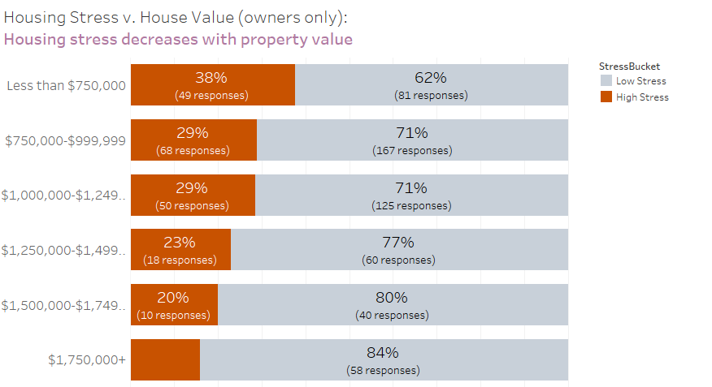

Although higher levels of housing stress are experienced at lower market values, there are also fewer projections of migration. (It may be that people feel trapped in their situation and warrants further study.)

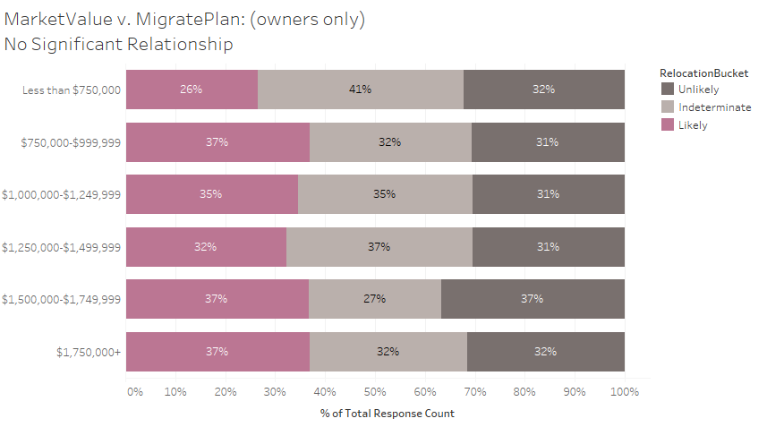

Property tax may be associated with higher levels of stress for those who find the majority of their housing cost is relatd to property taxes.

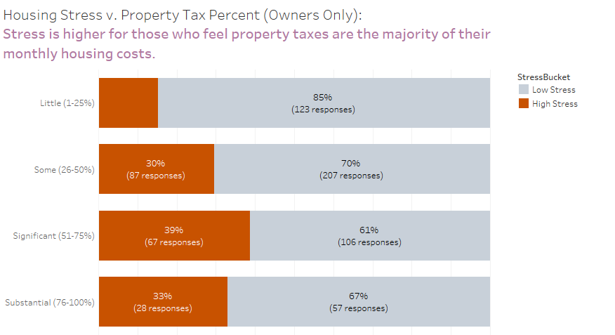

One possible measure of tax exemption (fairness or effectiveness?) would be whether lower service usage rates occur for those receiving exemptions. A small relationship between # of services and market value exists, while some relationship between LPS use and market value: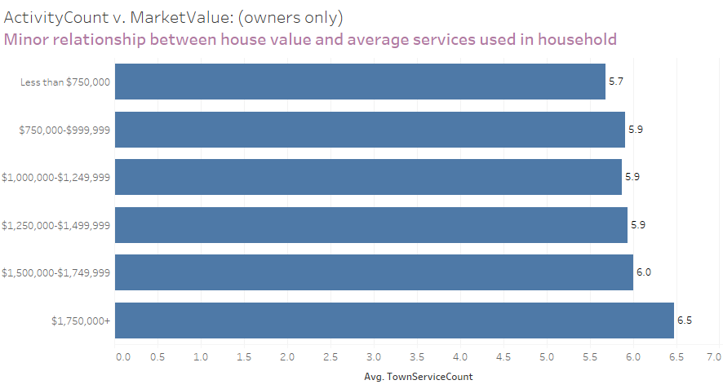

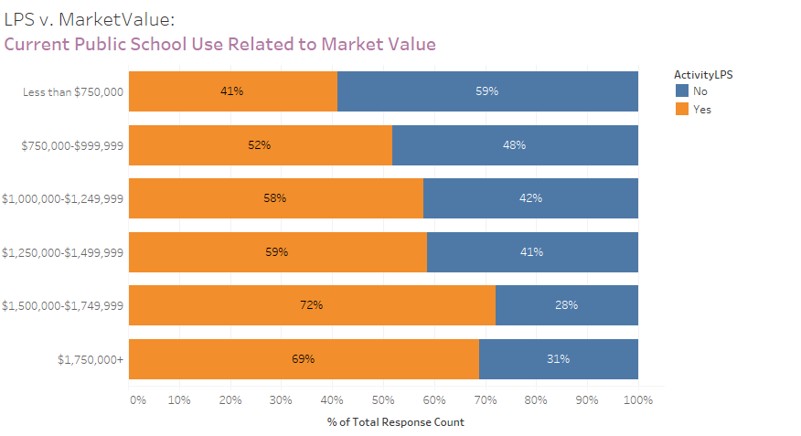

Means-tested residential exemption screens applicants based on income, and housing stress is higher among owners with lower income levels.

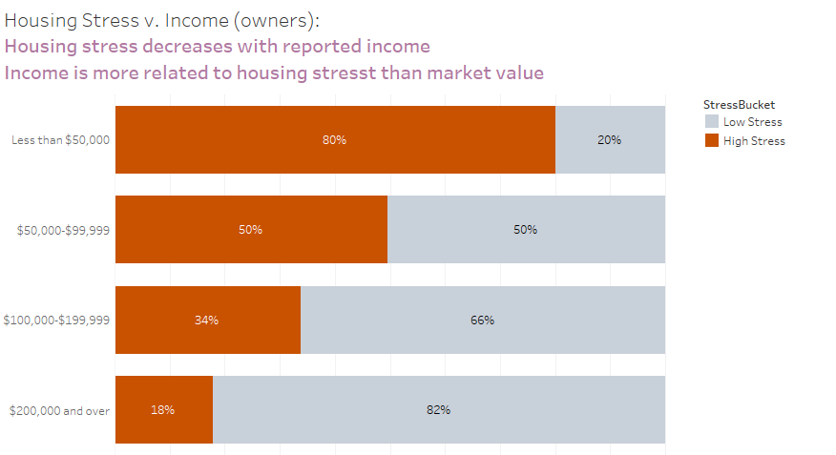

As with market value, lower incomes have higher stress and lower migration probability.

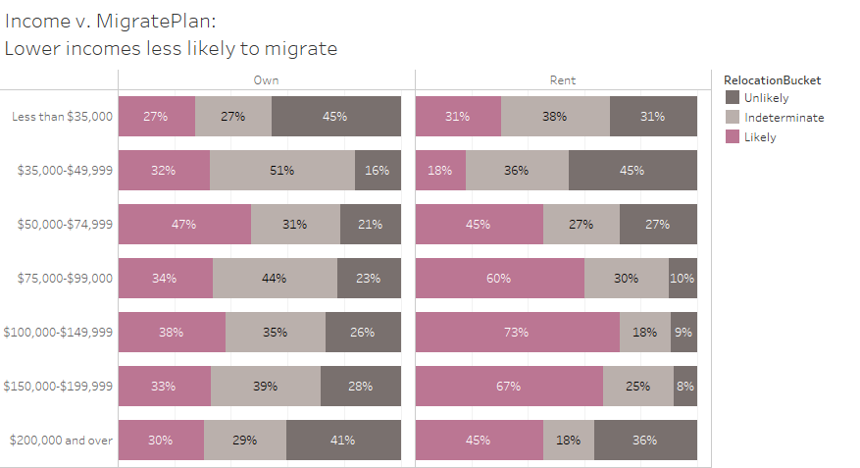

Housing stress is lower among 60-79 year olds than other age segments.

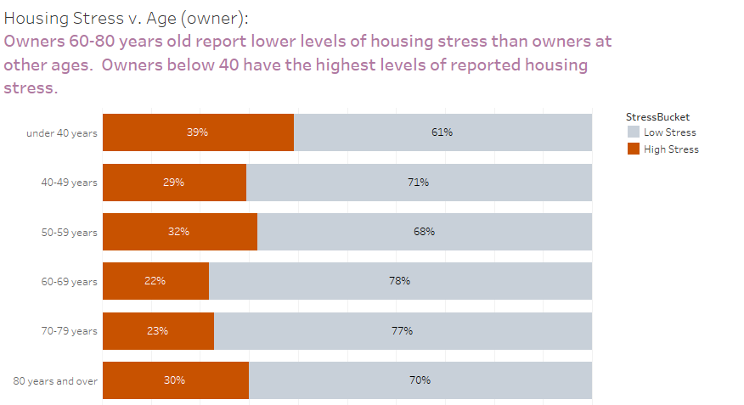

Use of the public schools is lower among respondents with income levels included in the means tested exemption.

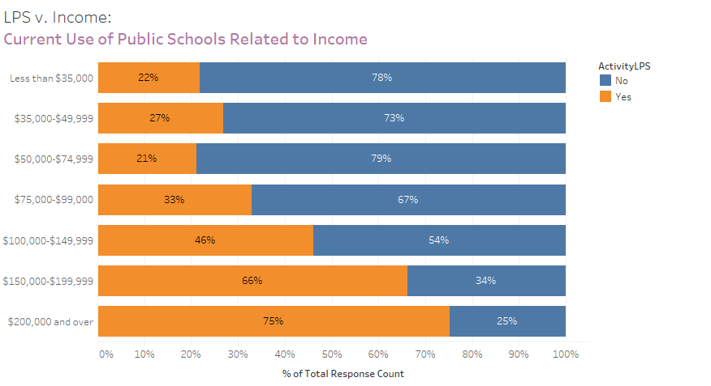

Means tested exemption targets those who have been in Lexington for some period of time. The survey suggests that newcomers experience the highest housing stress.

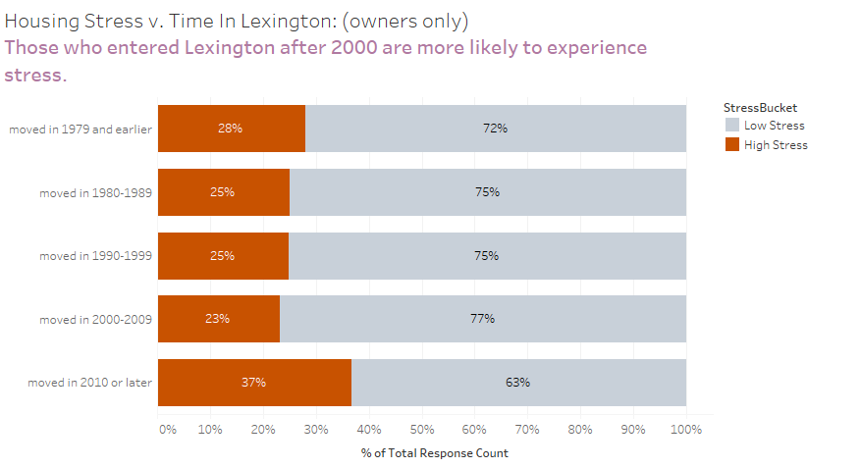

Using multiple survey categories we can identify respondents bearing rough approximation to measures for a means tested exemption:

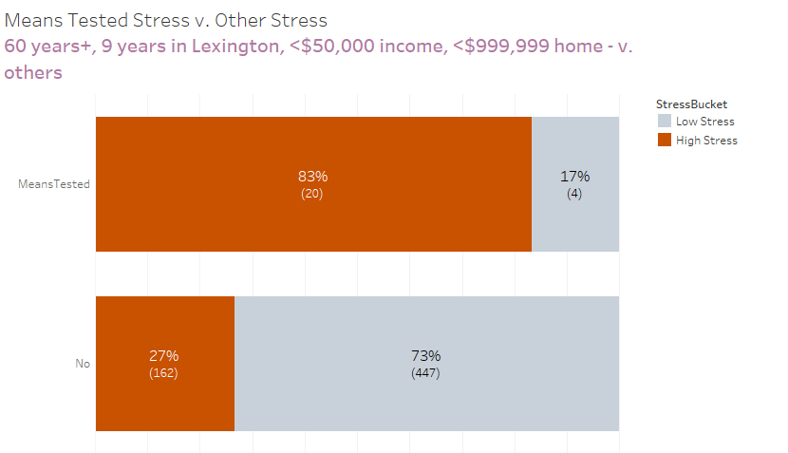

As with prior analyses, housing stress does not correlate directly with relocation probability:

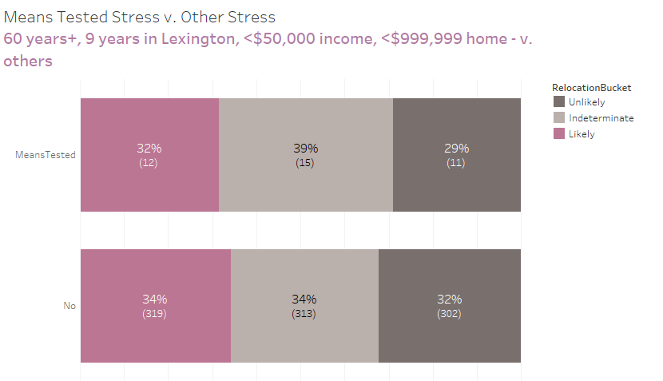

Respondents approximately means tested criteria use fewer town services.

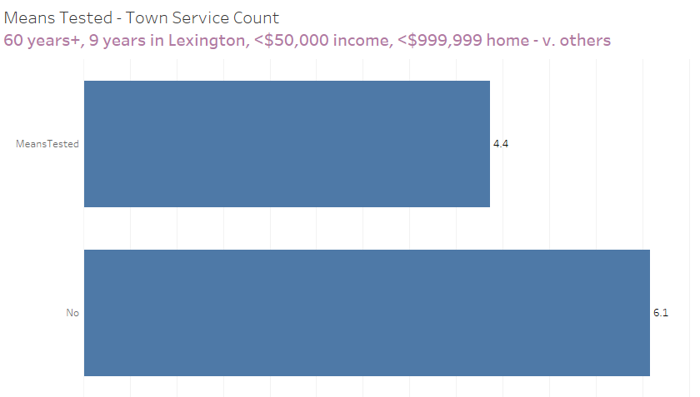

And respondents approximately means tested also are very unlikely to use public school services:

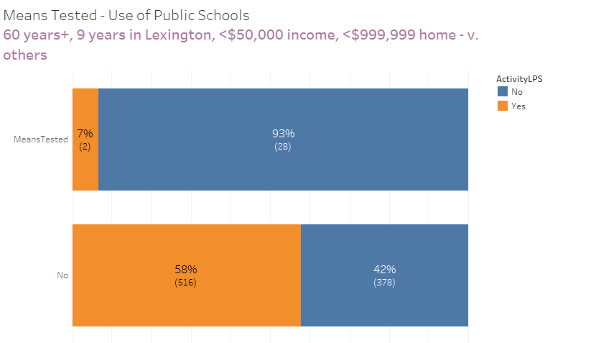

The committee’s charge is to understand whether a tax change would allow residents to remain in their homes. The data suggests that those with high housing stress are considerably more likely to consider relocation. The causal direction is uncertain, but it seems more plausible that housing stress in Lexington drives relocation decisions than the opposite relation.

(Interestingly some other relationships show income and market value not driving relocation.)

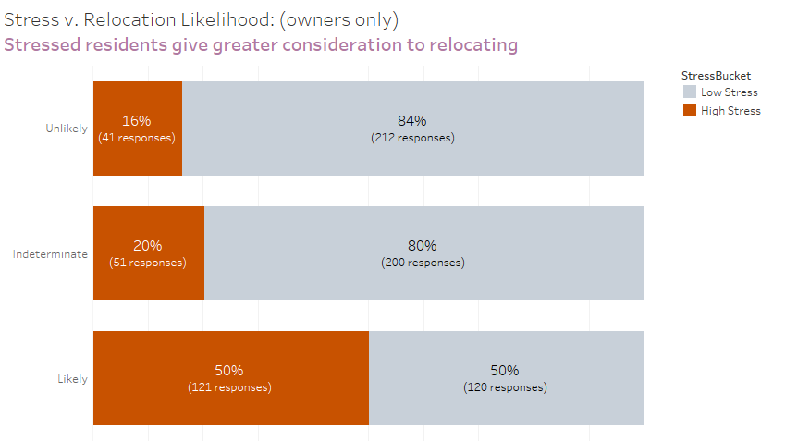

Some service use was correlated with likelihood to remain in Lexington, while other services were not.

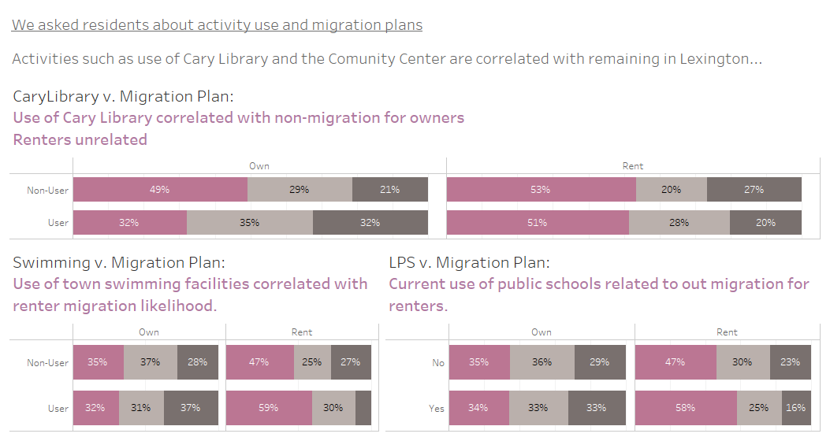

Survey responses can be used to roughly gauge owner occupancy rates for homes at 97% and condominiums at 85%.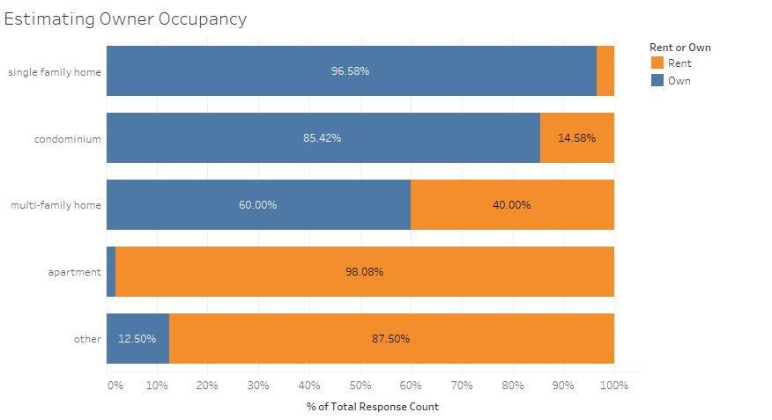

Descriptive Statistics

Responses on Migration

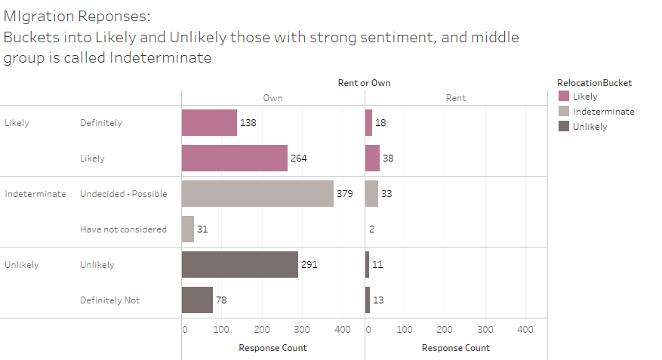**Further data analysis**:Quotes - summarization and analysis